LAPTOP REQUST CATLOG ITEM

**Team Id:** NM2025TMID19155

**Team Members:** 05

**Team Leader:** AJITH G

**Team Member 1:** CHARAN SAEE R

**Team Member 2:** MAGESH KUMAR M

**Team Member 3**: SARAN KUMAR D

**Team Member 4**: GANESH M

**Problem Statement:** Employees lack a standardized process to request laptops, leading to delaly

and miscommunication.  
 There is no centralized catalog item to streamline hardware requests in the system.  
 This results in inefficient approvals and tracking issues.

**Objective:** To create a centralized and user-friendly catalog item for laptop requests.  
 Ensure standardized request submission, approval, and fulfillment workflows.  
 Improve tracking, transparency, and turnaround time for hardware provisioning.  
 Enhance overall efficiency in IT asset management and user satisfaction.

**Skills:** Service Now,

Java Script,

Documentation**,**

**TASK INITIATION**

**Milestone 1 : Users**

**Activity 1: Create Users**

1. Open service now
2. Click on All >> search for users
3. Select Users under system security
4. Click on new
5. Fill the following details to create a new user
6. Click on submit

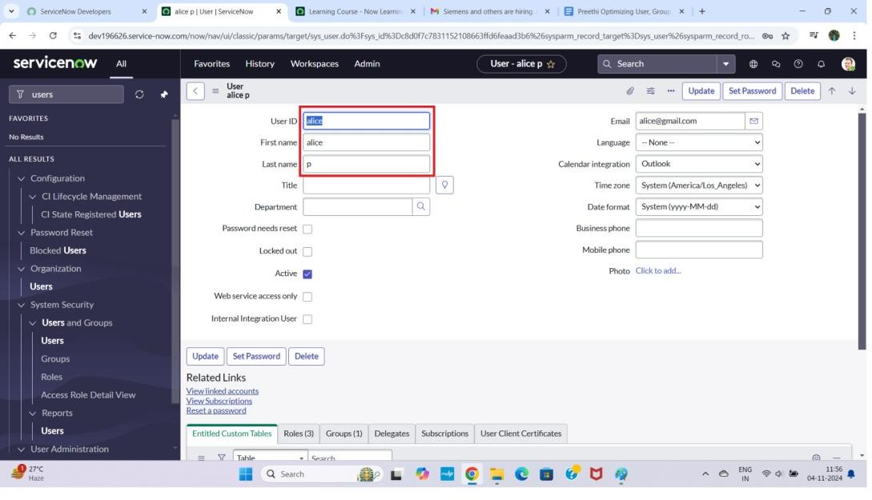

# Create one more user:

1. Create another user with the following details
2. Click on submit

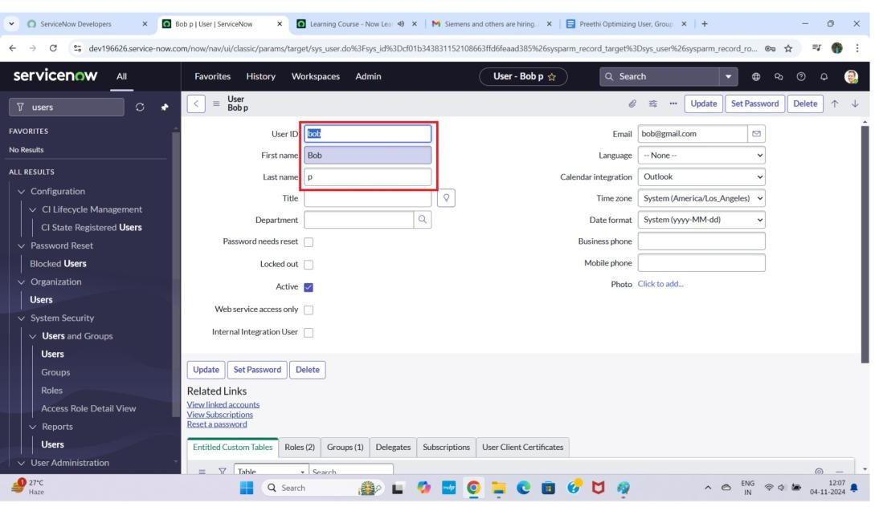

**Milestone 2 : Groups**

**Activity 1: Create Groups**

1. Open service now.
2. Click on All >> search for groups
3. Select groups under system security
4. Click on new
5. Fill the following details to create a new group
6. Click on submit

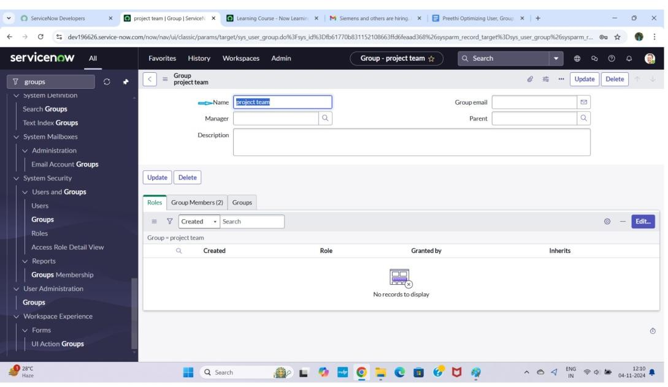

**Milestone 3 : Roles**

**Activity 1: Create roles**

1. Open service now.
2. Click on All >> search for roles
3. Select roles under system security
4. Click on new
5. Fill the following details to create a new role
6. Click on submit

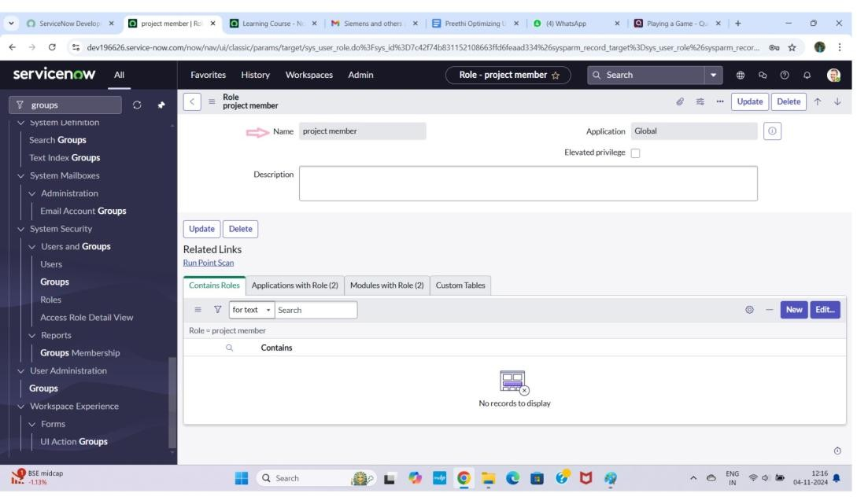

# Create one more role:

1. Create another role with the following details
2. Click on submit

**Milestone 4 : Table Activity 1: Create Table**

1. Open service now.
2. Click on All >> search for tables
3. Select tables under system definition
4. Click on new
5. Fill the following details to create a new table Label : project table

Check the boxes Create module & Create mobile module

1. Under new menu name : project table
2. Under table columns give the columns

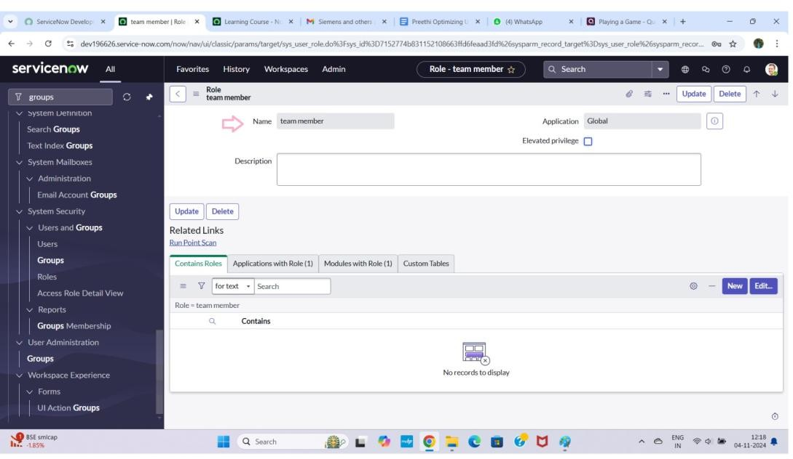

1. Click on submit

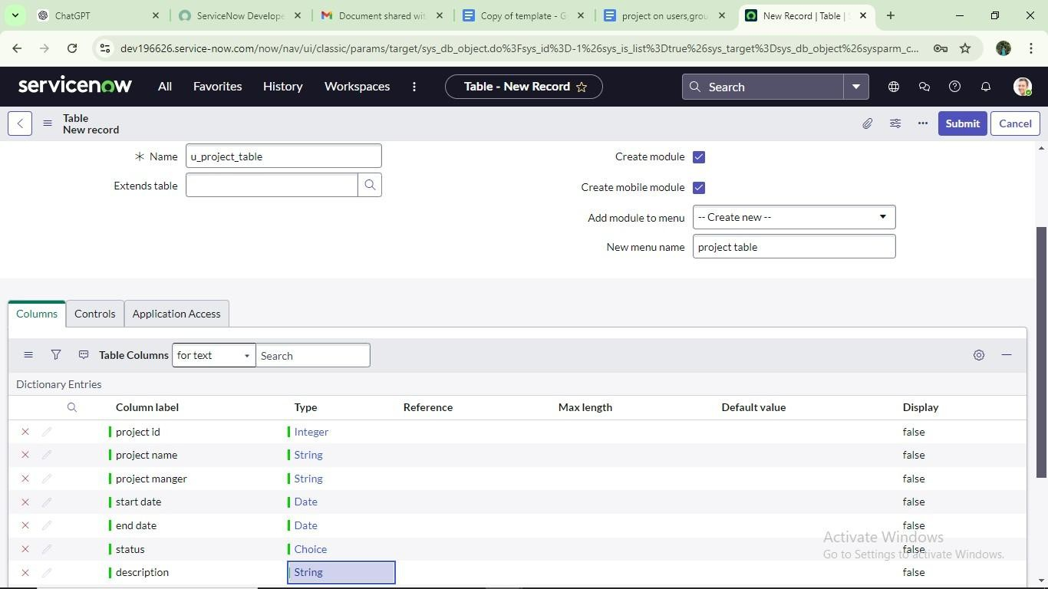

# Create one more table:

1. Create another table as:task table 2 and fill with following details.
2. Click on submit.

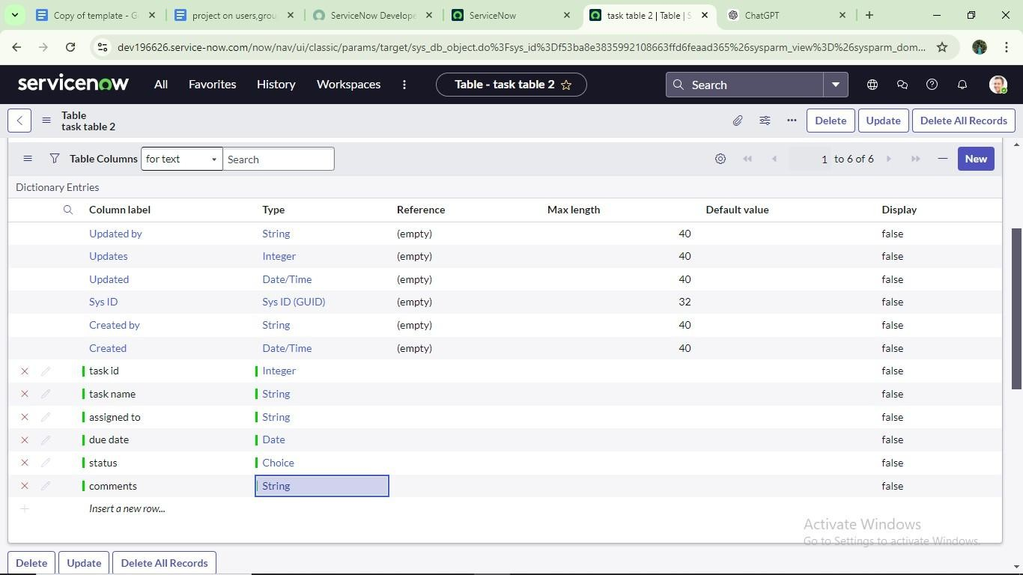

**Milestone 5 : Assign users to groups**

**Activity 1: Assign users to project team group**

* 1. Open service now.
  2. Click on All >> search for groups
  3. Select tables under system definition
  4. Select the project team group
  5. Under group members
  6. Click on edit
  7. Select alice p and bob p and save

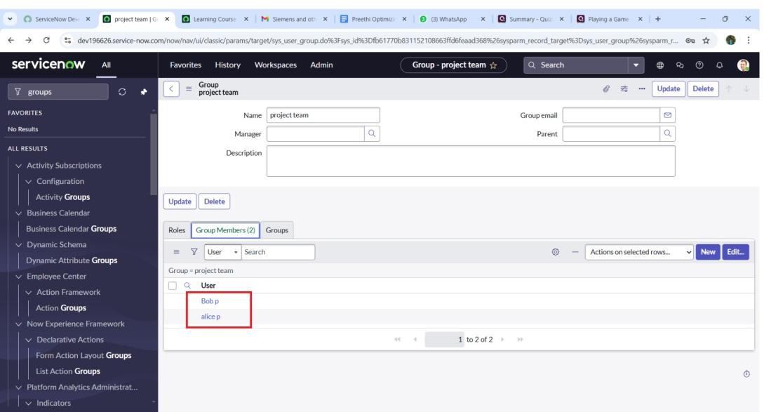

**Milestone 6 : Assign roles to users Activity 1: Assign roles to alice user**

1. Open servicenow.Click on All >> search for user
2. Select tables under system definition
3. Select the project manager user
4. Under project manager
5. Click on edit
6. Select project member and save
7. click on edit add u_project_table role and u_task_table role
8. click on save and update the form.

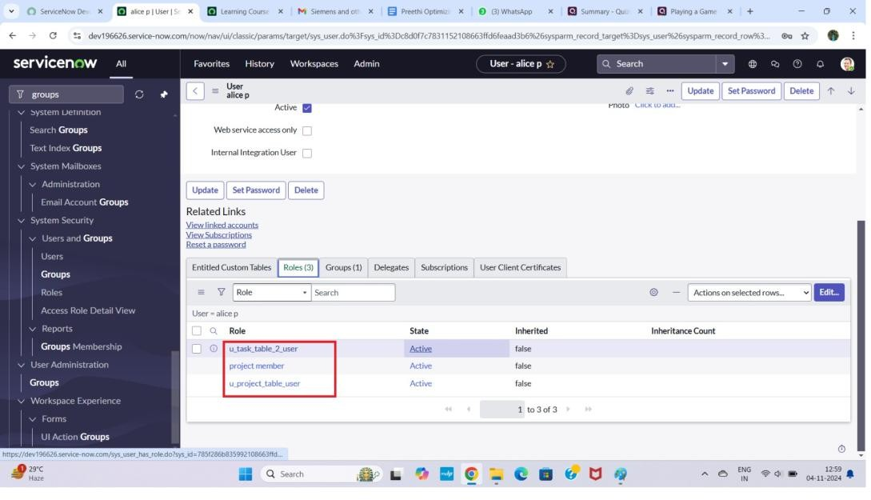

**Activity 2: Assign roles to bob user**

1. Open servicenow.Click on All >> search for user
2. Select tables under system definition
3. Select the bob p user
4. Under team member
5. Click on edit
6. Select team member and give table role and save
7. Click on profile icon Impersonate user to bob
8. We can see the task table2.

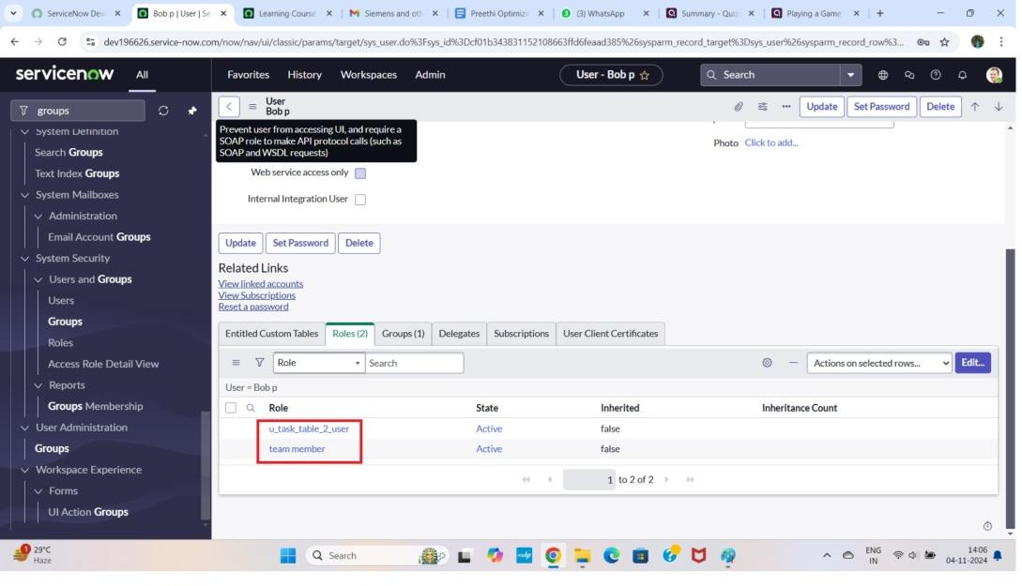

**Milestone 7 : Application access**

**Activity 1: Assign table access to application**

1. while creating a table it automatically create a application and module for that table
2. Go to application navigator search for search project table application
3. Click on edit module
4. Give project member roles to that application
5. Search for task table2 and click on edit application.
6. Give the project member and team member role for task table 2 application

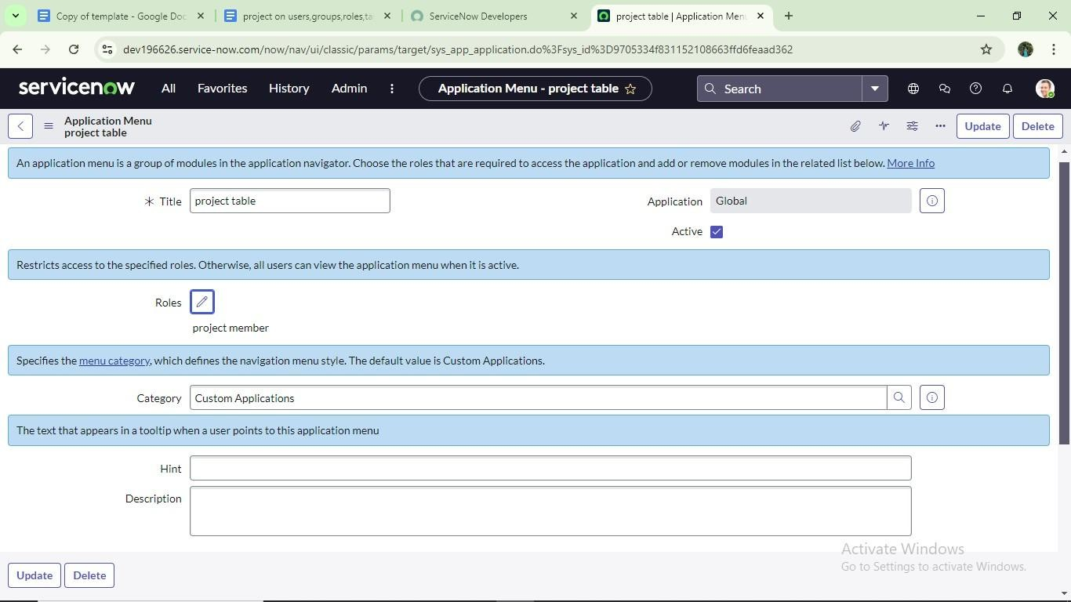

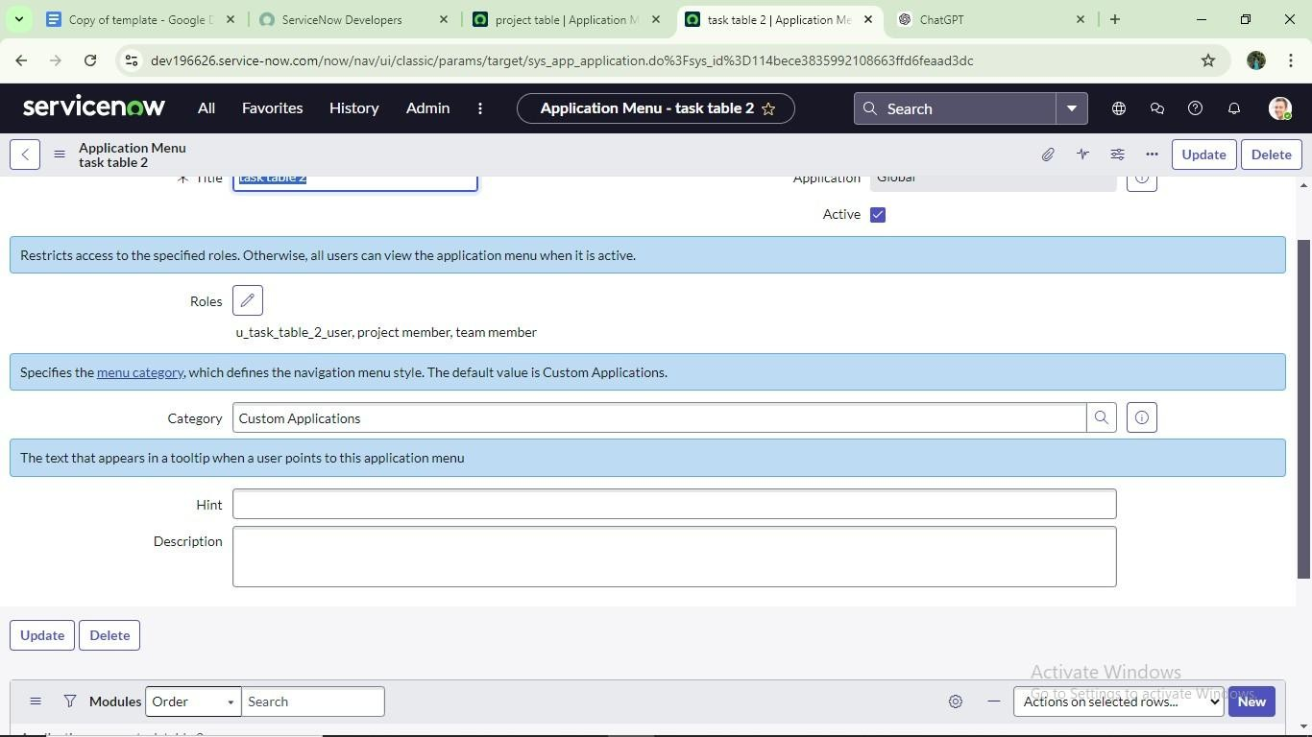

**Milestone 8 :Access control list Activity 1: Create ACL**

1. Open service now.
2. Click on All >> search for ACL
3. Select Access Control(ACL) under system security
4. 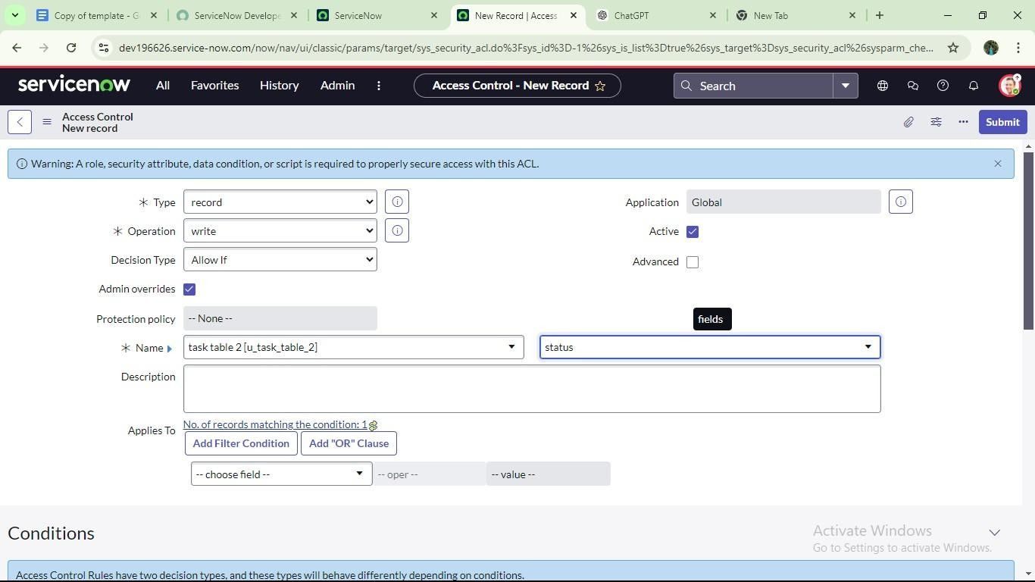Click on elevate role 5. Click on new
5. Fill the following details to create a new ACL
6. Scroll down under requires role
7. Double click on insert a new row
8. Give task table and team member role
9. Click on submit
10. Similarly create 4 acl for the following fields

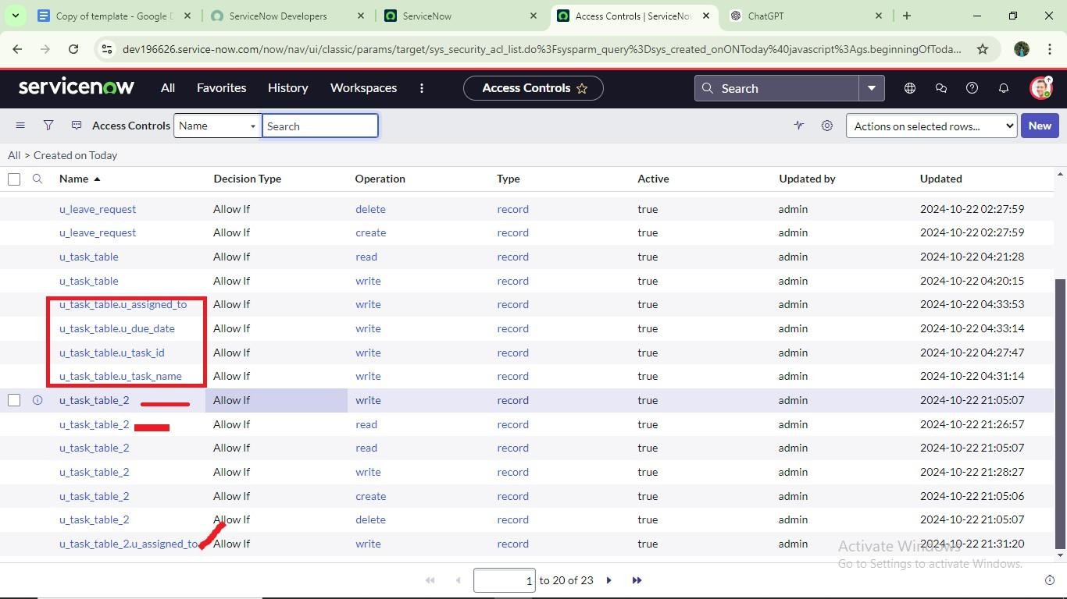

1. Click on profile on top right side
2. Click on impersonate user
3. Select bob user
4. Go to all and select task table2 in the application menu bar
5. Comment and status fields are have the edit access

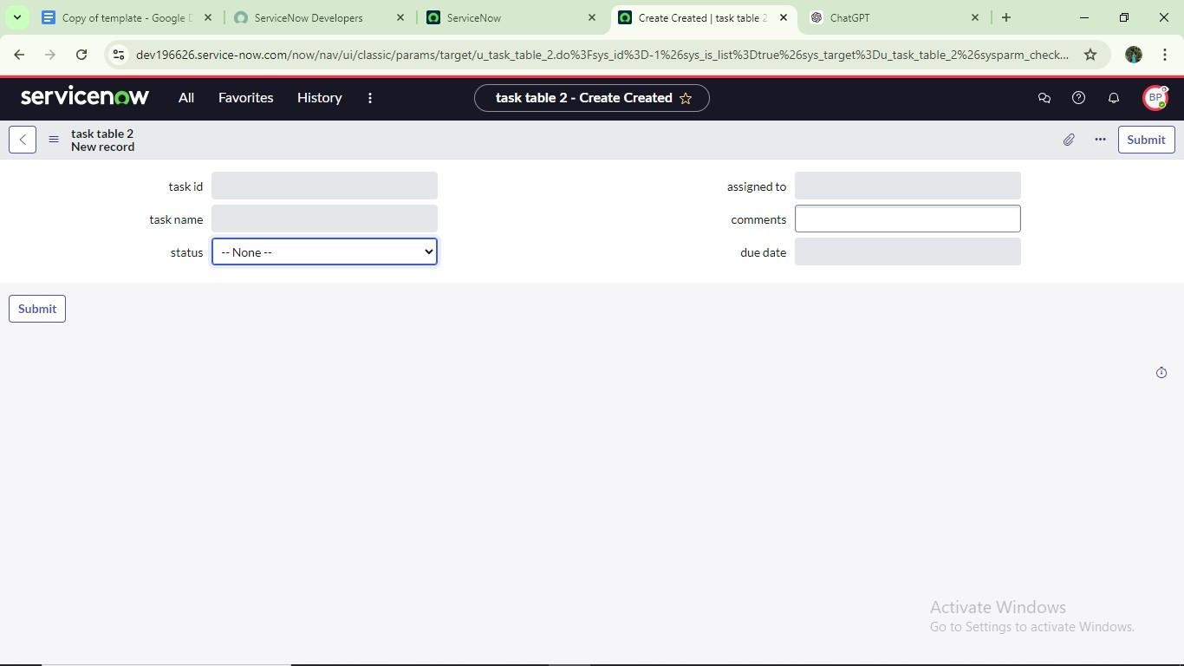

**Milestone 9: Flow**

**Activity 1: Create a Flow to Assign operations ticket to group**

1. Open service now.
2. Click on All >> search for Flow Designer
3. Click on Flow Designer under Process Automation.
4. After opening Flow Designer Click on new and select Flow.
5. Under Flow properties Give Flow Name as “ task table”.
6. Application should be Global.
7. Click build flow.

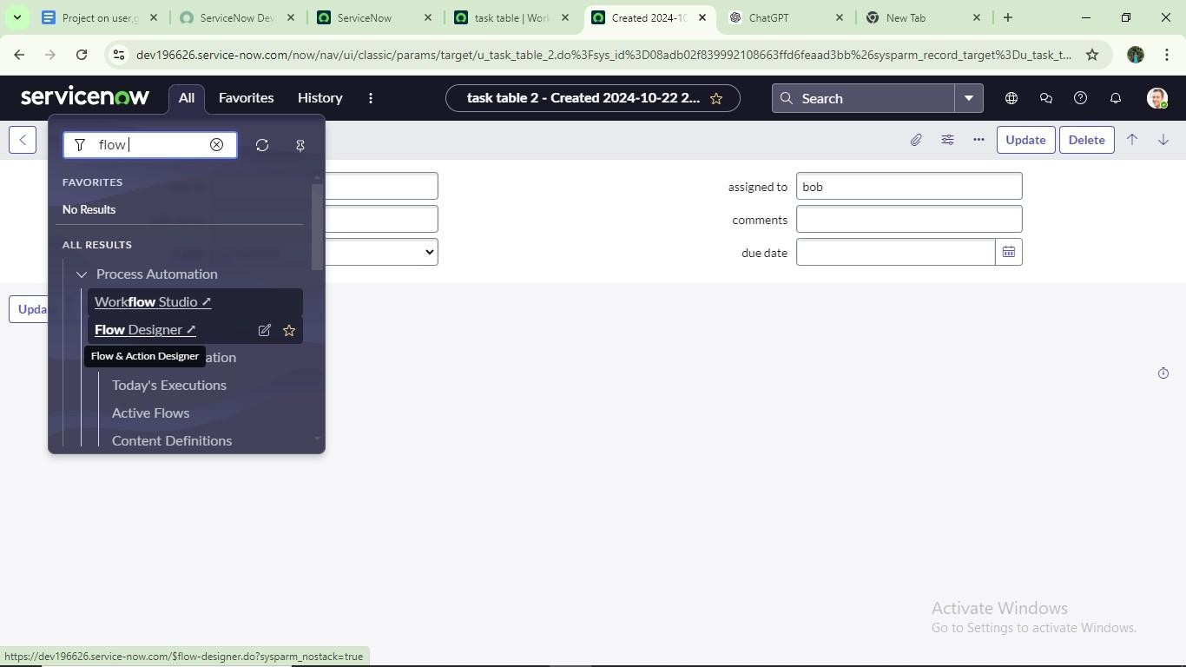

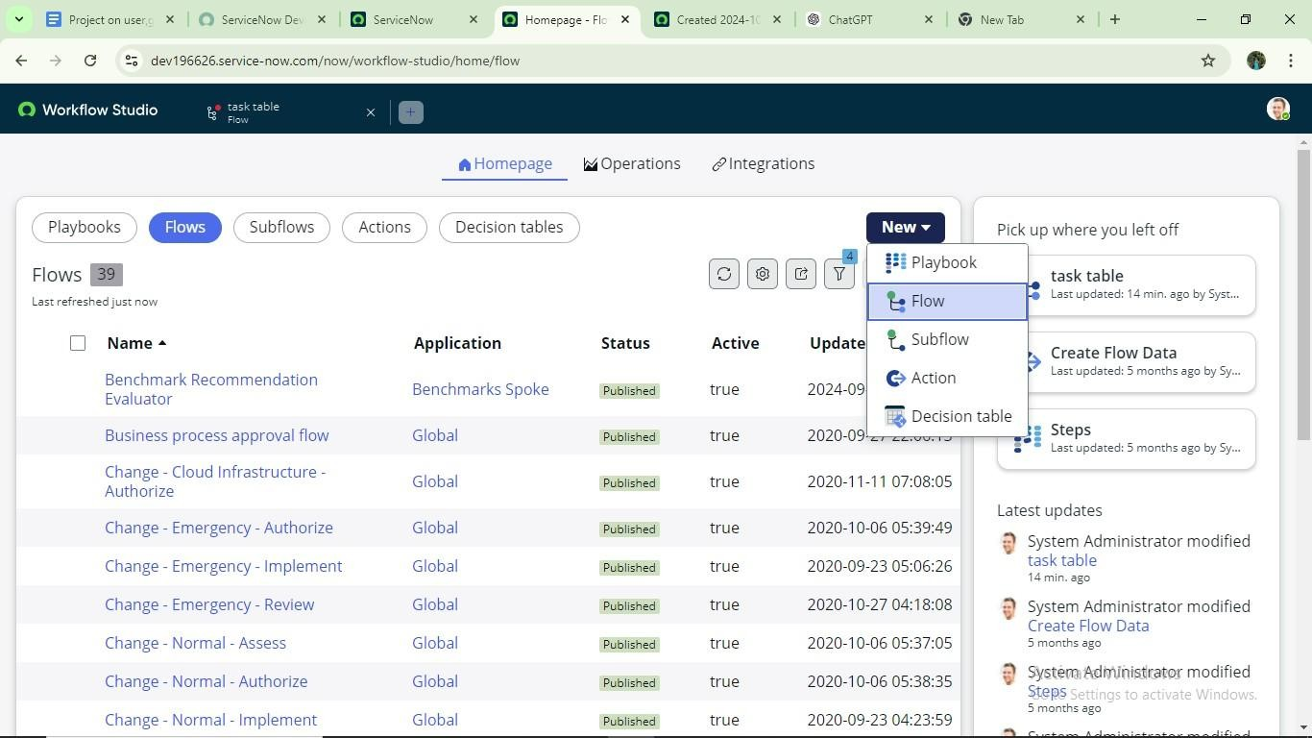

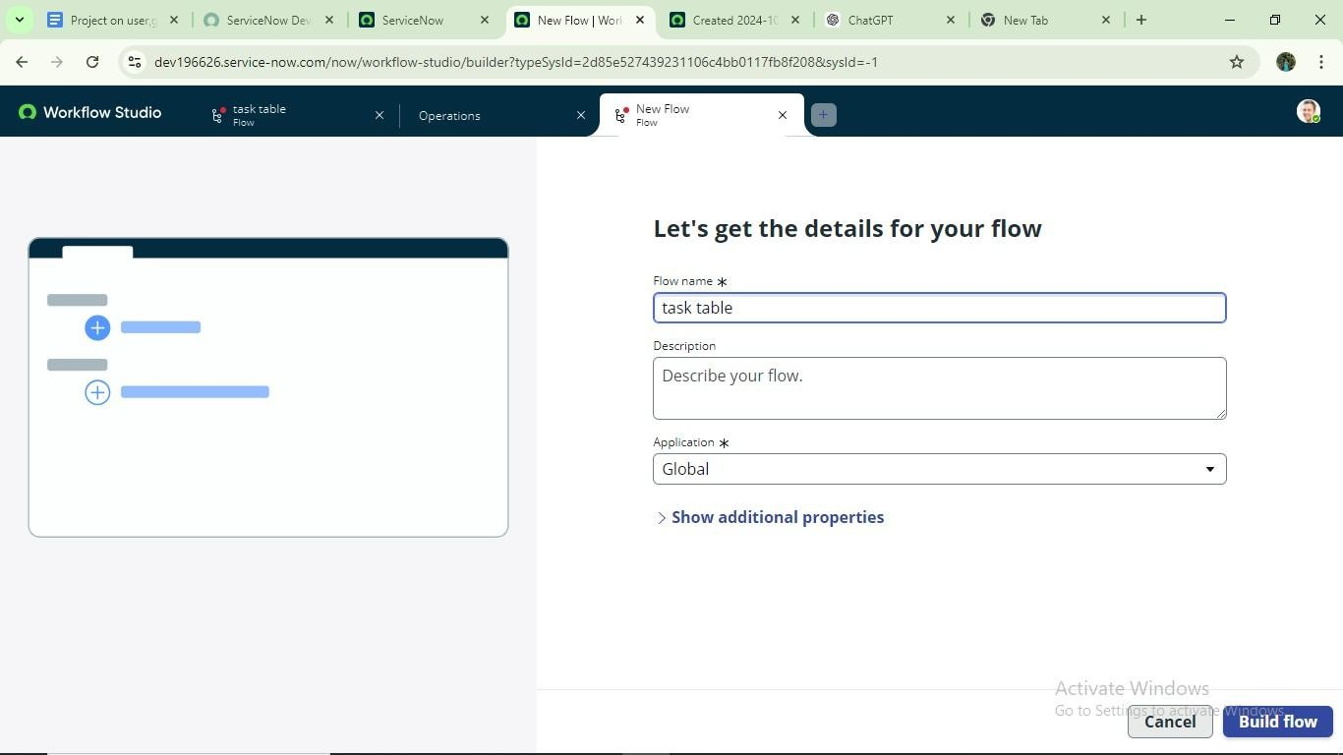

# next step:

1. Click on Add a trigger
2. Select the trigger in that Search for “create record” and select that.
3. Give the table name as “ task table ”.
4. Give the Condition as Field : status Operator :is Value : in progress Field : comments Operator :is Value : feedback

Field : assigned to Operator :is Value : bob

1. After that click on Done.

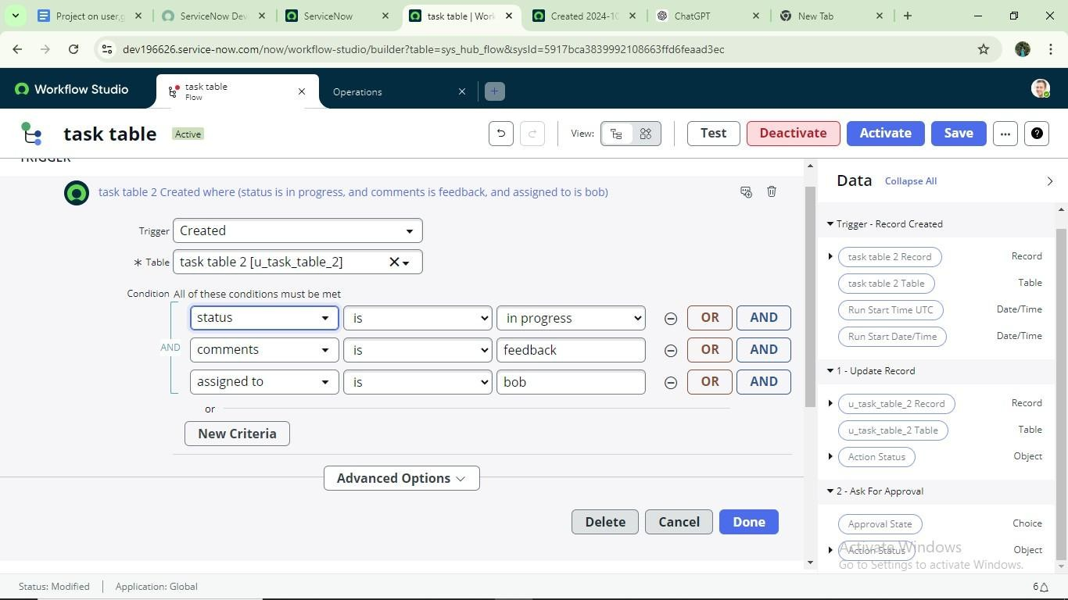

# Next step:

1. Click on Add an action.
2. Select action in that ,search for “ update records”.
3. In Record field drag the fields from the data navigation from Right Side(Data pill)
4. Table will be auto assigned after that
5. Add fields as “status” and value as “completed”
6. Click on Done.

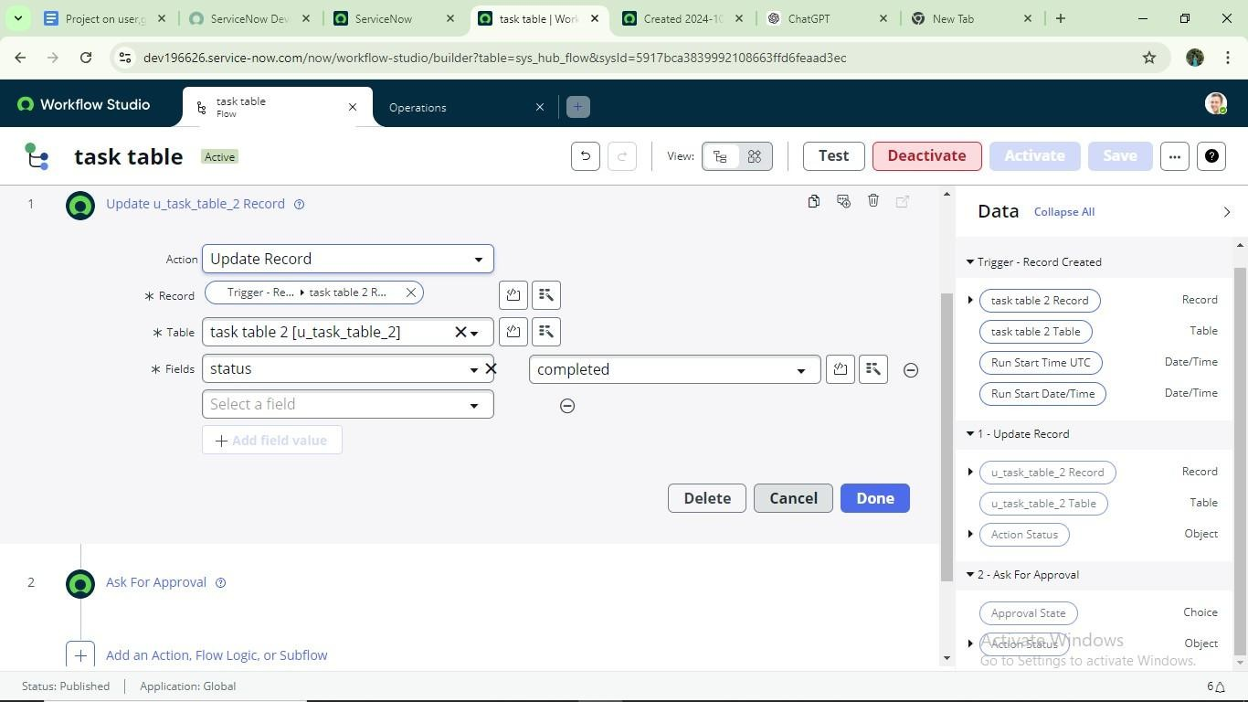

# Next step:

1. Now under Actions.
2. Click on Add an action.
3. Select action in that ,search for “ ask for approval ”.
4. In Record field drag the fields from the data navigation from Right side
5. Table will be auto assigned after that
6. Give the approve field as “ status” 7. Give approver as alice p
7. Click on Done.

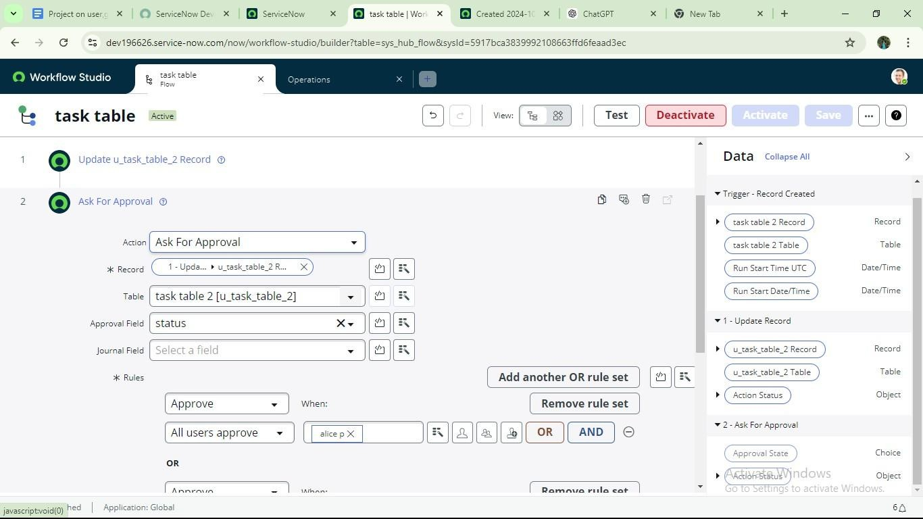

1. Go to application navigator search for task table.
2. It status field is updated to completed

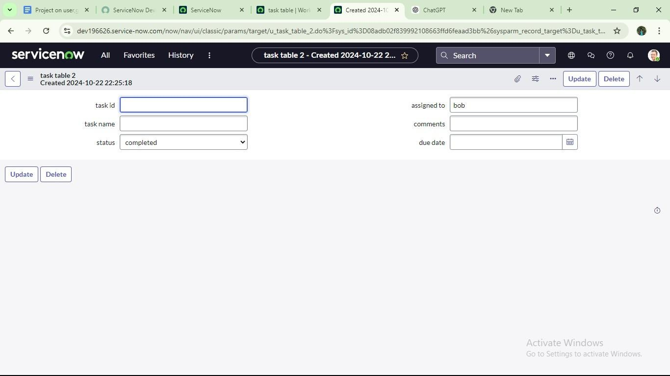

1. Go to application navigator and search for my approval
2. Click on my approval under the service desk.
3. Alice p got approval request then right click on requested then select approved

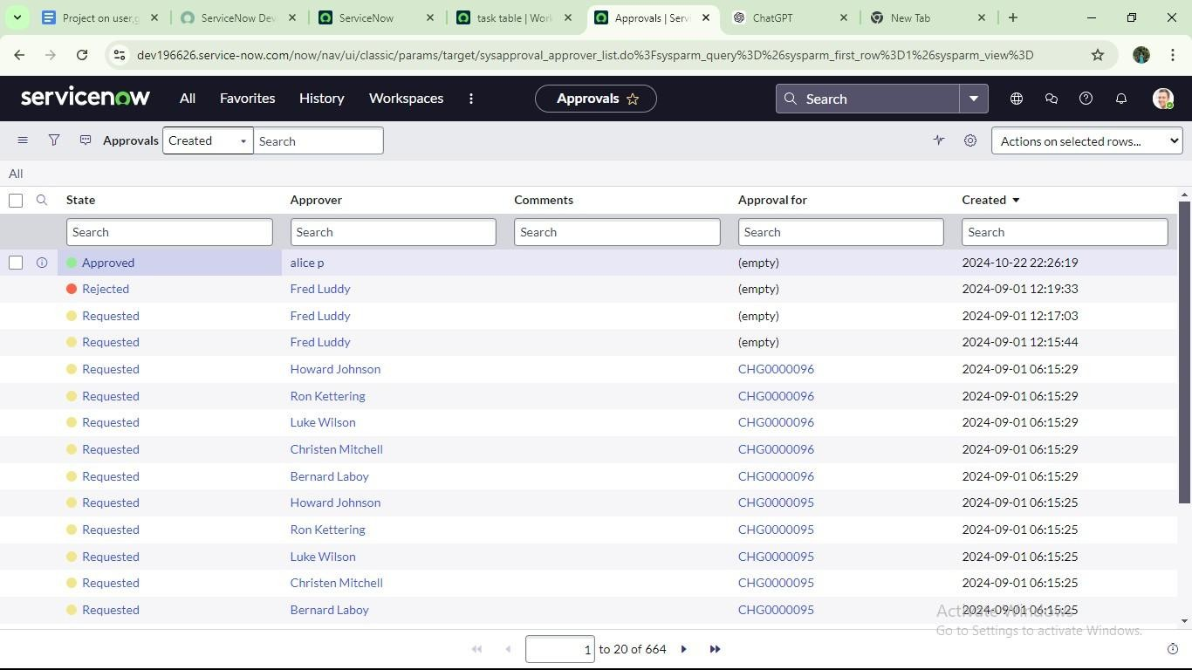

**Conclusion :**